Toastmasters Educational Program

Communication and Leadership Development
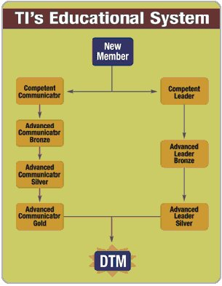
The educational program is the heart of every Toastmasters club. It provides members with a proven curriculum that develops communication and leadership skills one step at a time, with many opportunities for awards and recognition along the way. The communication and leadership tracks are not mutually exclusive; you may participate in both at the same time, if you wish.
You progress along each track by working through a series of manuals, each of which offers a set of carefully crafted projects to complete.
Each project includes an evaluation guide, which gives club members an easy way to provide immediate feedback as the project is completed.
Once you become a member, you can begin the educational program right away.
The New Member Kit includes the following manuals to get you started in both tracks:
- Competent Communication
- Competent Leadership
- Your Speaking Voice
- Effective Evaluation
- Gestures: Your Body Speaks
Courtesy of: Suezy Proctor, DTM
International Director Candidate, Region 1
www.thespeechdoctor.com

